Meaning is always here
I started the curation of Meaning is Always Here by trying to imagine a persona the Marjorie Barrick Museum of Art might present to Nevadans that live far away and cannot reach us. We at the Museum think we have a good sense of who we are, but how do others perceive us? We shift. Our exhibitions change. Therefore, this exhibition should show that change with artists from different backgrounds and media. The works should reference the real world and represent a transformation through the artists’ decisions, so that we can see where they’re coming from.

Artists face the problem of self- interpretation every time they create work. Mikayla Whitmore, standing in the desert outside Las Vegas, dons a reflective blanket to illustrate an idea that has circulated through their practice for years: the tension between wanting to be known and the desire to maintain your privacy. How do you control what people see of you? Chase
R. McCurdy – another Las Vegan – suggests his ideas through a meticulous symbolic vocabulary that differentiates him from the other Black artists in our collection. Like Whitmore, he concentrates on indirectness.

The Marjorie Barrick Museum of Art is pleased to loan this artwork from our permanent collection to the Nevada Arts Council. Our goal is to help broaden the Museum’s message that everyone deserves access to art that challenges our understanding of the present and inspires us to create a future that holds space for us all.

Exhibition artists include: Alexander Calder, Mikayla Whitmore, Tomoko Daido, Stephen Antonakos, Chase R. McCurdy, Kim Rugg, Candice Lin, Krystal Ramirez, Lucio Pozzi, Mary Cady Johnson, and Marshall Scheuttle

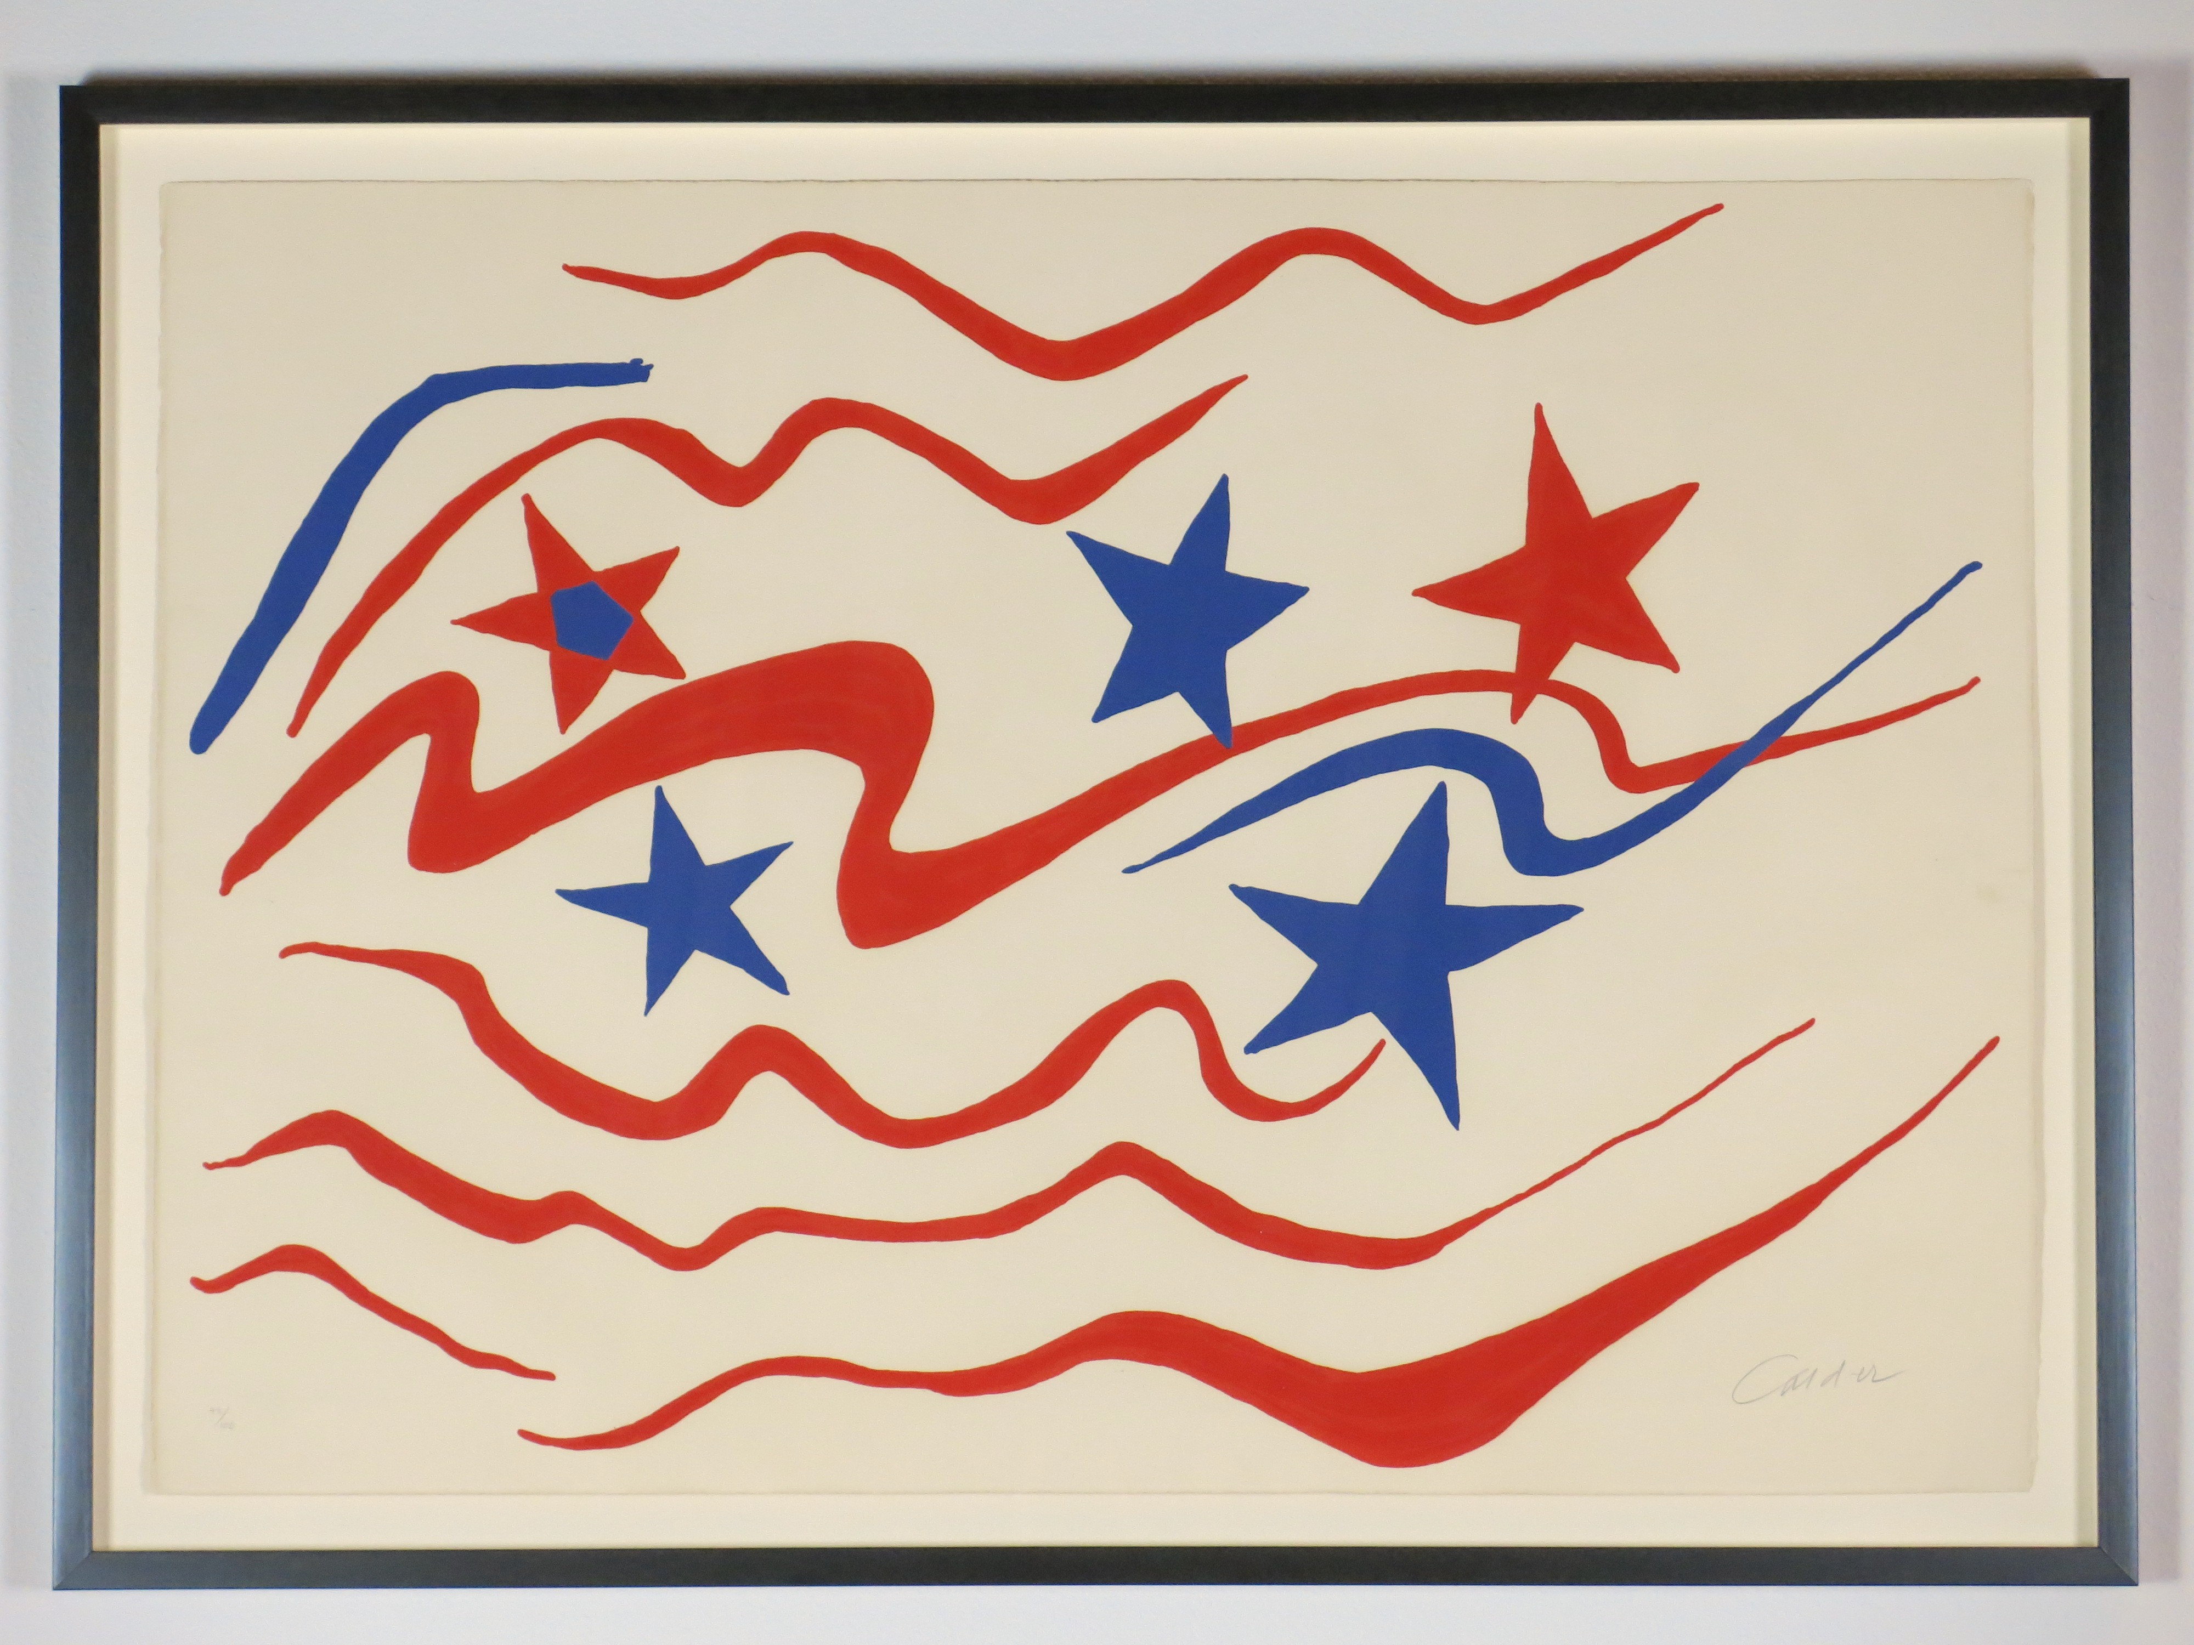

Flying Colors
Alexander Calder
Lithograph on paper
28.5 x 29.125 x 1.25 in
1976

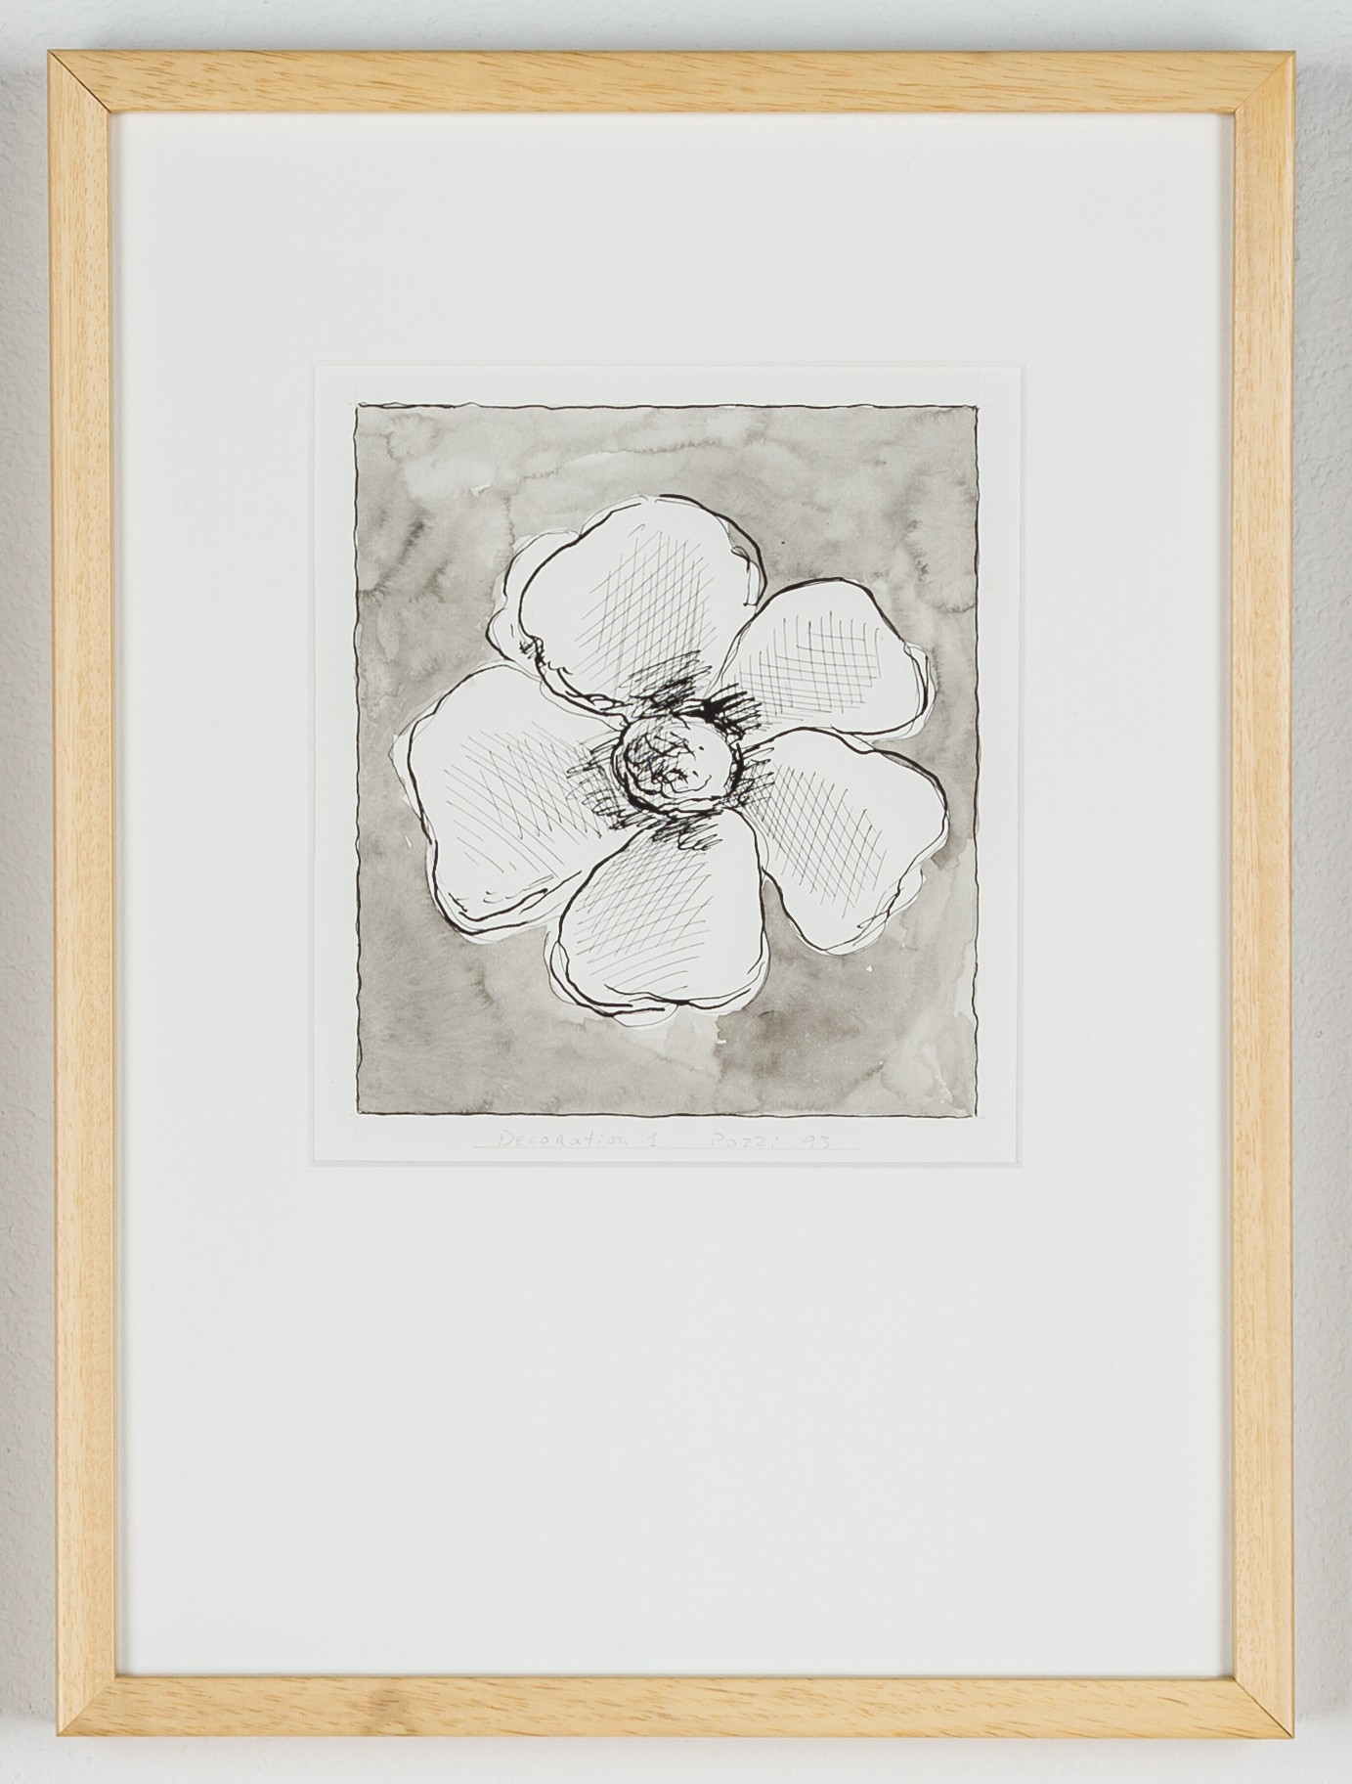

Decoration 1
Lucio Pozzi
Watercolor and ink on paper
18.875 x 14 x 1.75 in
1993
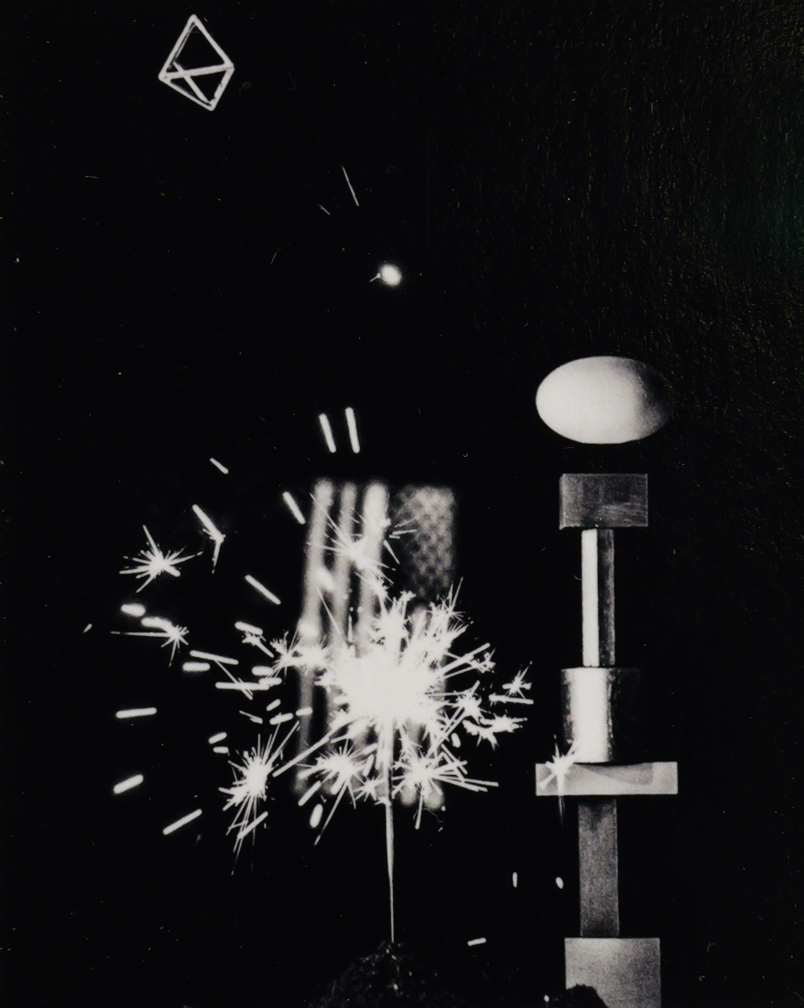

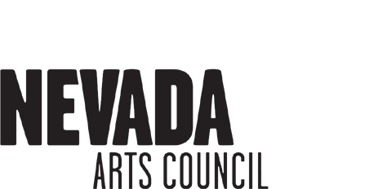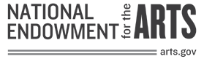Should we draw attention to details that change us? Marshall Scheuttle looked at a motel in Reno and saw how the architectural grid was altered by the casual existences of people.
Nevada Touring Initiative
CURATED BY Marjorie Barrick
Museum of Art Staff for the Nevada Arts Council Essay written by Deanna Sole
CONTENTS
14 pieces of art Introduction panel & wall tags Quad-Fold with essay in English
and Spanish
LINEAR FEET
Approximately 55 linear feet

RENTAL FEE
$150 for 8 weeks
AVAILABILITY
October 24, 2022 to December 1,
2024
For schedule information call
775.687.7108xxxxxx
Tomoko Daido, a New Yorker, visited the Hoover Dam and saw something weird in the monumental concrete, a vision around the shape of a ladder.

Don’t Say I Didn’t WARN You…
Chase R. McCurdy
Digital C-print
17 x 14 in
1993

